Title:

Effects of short-interval disturbances continue to accumulate, overwhelming variability in local resilience

Katherine Hayes1, Brian Buma1

Author Affiliations:

1University of Colorado Denver, Department of Integrative Biology

* Correspondence to katherine.hayes@ucdenver.edu

Abstract:

Increasing rates of ecological disturbance, and in particular short-interval disturbances, have the potential to rapidly transform ecosystems, often triggering community shifts to alternate stable regimes. While research has explored these compound events in multiple biomes, little is known as to the consequences of continued high frequency events – in other words, what happens when those new communities are themselves subject to short-interval disturbances? Furthermore, little is known about how variations in intensity matter for these ongoing changes. We report on work that examines the role of 1) ongoing short-interval fires in transformed landscapes and 2) landscape-driven variability in intensity to continued transformation of boreal forests ecosystems. We established 50 plots across a mosaic of fire histories (1, 2 or 3 fires in <70 years) in an upland and lowland site in Interior Alaska. We compared abundance, proportion and density of conifer and deciduous regeneration in a drier upland site and a wetter lowland site. Both sites were originally dominated by black spruce. In the drier upland site, black spruce presence declined sharply after two fires while paper birch (*Betula neoalaskana*) became increasingly abundant with each additional fire. In the wetter lowland site, less organic soil was consumed by fire and presence of black spruce persisted through an initial single reburn (two fires), indicating local topography may buffer the impact of reburning temporarily. However, after three burns, conifers were effectively eliminated in both upland and lowland stands. Continued reburning in deciduous stands promoted increasing dominance and shifts in of deciduous species. Deciduous regeneration differed between topographic position: birch dominated in upland plots while willow (*Salix spp.)* and aspen (*Populus tremuloides*) dominated in lowlands. Results of this study offer strong empirical evidence of the divergence of boreal successional trajectories from previous historic norms. More broadly, this demonstrates that the effects of ongoing, short- interval disturbances continue to accumulate and that frequency can overwhelm variation in intensity in terms of ecosystem resilience.

**Keywords:** boreal, reburns, regime shifts, succession, fire frequency, ecosystem transformation

# Introduction

Disturbances are a major driver of long-term ecosystem functioning, and in many ecosystems are the major force that creates and maintains ecosystems themselves (e.g., grassland vs. forests, Dantas et al. 2016). Species have evolved various adaptations to avoid, recover from, or take advantage of disturbances. Theory suggests that in disturbance-adapted systems, ecosystems can recover via resilience mechanisms after even intense disturbances (“ecological memory,” Johnstone et al. 2016). However, if additional disturbance events occur within the timeframe of recovery, those resilience mechanisms can be overwhelmed, creating “ecological surprises” (Paine et al. 1998), meaning recovery trajectories not easily predictable from knowledge of the individual disturbance agents themselves (Scheffer and Carpenter 2003, Buma 2015). Examples abound, both terrestrial and aquatic – from changes in bamboo communities after fires and floods (Gagnon 2009), coral reef phase shifts after fishing and hurricanes (Hughes 1994), and experimental aquatic mesocosm studies (Kercher and Zedler 2004). If there is a long-term shift to different disturbance regimes (e.g., higher frequency) or other feedbacks, the new community types can persist, driving fundamental shifts in ecosystem functioning (e.g., grazing and fires, Archibald et al. 2005; coral reef functioning, Jones et al. 2004). Theoretical modeling agrees, and further suggests changes in disturbance frequency are more important than changes to intensity or other disturbance characteristics (Fraterrigo et al. 2020) in driving variability in recovery.

Research into the effects of disturbance frequency changes have almost exclusively focused on high intensity disturbances and single short-interval events (two disturbances). At least two major gaps remain. First, little empirical research has been conducted on the ongoing effects of short-interval events. While modeling suggests progressive loss in ecosystem functions (e.g., ongoing fires in Yellowstone, Westerling et al. 2011), it is also true that subsequent disturbances interact with previous disturbance conditions, changing intensity and overall impacts which can limit future disturbance intensity or even occurrence (Parks et al. 2015, Buma et al. 2020). Trajectories inferred from single short-interval events may therefore not be valid if frequency of disturbances remains high. Second, little research has been directed towards repeat disturbances with varying intensity. Effects on ecosystems are mediated by external factors, such as topography. Theoretically, this should lessen cumulative impacts (Paine et al. 1998), though if frequency is truly the most significant factor (Fraterrigo et al. 2020) then that moderation effect should disappear with ongoing events. This too has not been empirically investigated.

Here we test those theories directly in a disturbance adapted biome, by looking at 1-3 events in short succession across two topographic contexts known to mediate disturbance severity. If changes continue to accrue with a continued high disturbance frequency, we should see ongoing divergence between each disturbance history; similarly, if frequency is the most important driver of ecosystem recovery trajectories, we should see resilience erode even in favored, historically more resilient/resistant to change topographic contexts.

We use fires and boreal forests as our test system. Fires are one of the most significant drivers of ecosystem change; on average 464 Mha burn each year (Randerson et al. 2012; no significant trend over the past decade, Forkel et al. 2019). Fire is responsible for 22% of global forest loss (Curtis et al. 2018), and in certain areas is even more significant (North America: 40% of forest loss; Asia: 58%, Australia/Oceania: 53%). Fire is the primary disturbance in boreal systems (Kurkowski et al. 2008), driving an overall loss in forest cover second only to deforestation in the tropics in terms of area (Hansen et al. 2013). Globally, there is a strong expectation for increased wildfires, and subsequent concern about ecosystem viability, in Europe, Africa, and North America (IPCC 2014). Because boreal forests are globally significant in terms of permafrost (Mann et al. 2012) and carbon stocks (Alexander et al. 2012) and are highly fire adapted and warming rapidly, they are ideal to test theory related to changes in disturbance frequency, multiple disturbances, and ecosystem resilience.

Boreal fire return intervals were historically >100 years in Interior Alaska (Yarie 1981, Viereck 1983, Johnstone et al. 2010). These forests are highly resilient to fire. The predominant post-fire successional pathway in boreal Interior Alaska is self-replacement (Kurkowski et al. 2008, Ott et al. 2006). Black spruce (*Picea mariana*) typically self-replaces within 10 years via a large canopy seedbank after fire (Kurkowski et al. 2008, Johnstone et al. 2004). Short-interval fires (essentially any return interval shorter than the time required to regenerate capacity for resilience to a fire) can consume local serotinous seedbanks, extirpating local populations and facilitating rapid forest type conversion (Buma et al. 2013, Enright et al. 2015). Loss of aerial seedbanks can favor wind-dispersed species with longer dispersal distances (McCaughey et al. 1985, Marquis et al. 1969, Burns and Honkala 1990), which can better colonize from outside burn perimeters (Brown and Johnstone 2012). Models suggest short-interval fires will lead to a shift in local community composition from conifer-dominated stands to deciduous forest (Mann et al. 2012, Roland et al. 2019, Rupp et al. 2002) or grassland (Brooks et al. 2004, Roland et al. 2013). Here, we define short interval fires as <30 years because research suggests 50 years or more are required for full aerial seedbank regeneration (Johnstone et al. 2004).

Under shortening fire intervals, black spruce self-replacement may be further disfavored by the interactive effect of soil consumption (a metric of intensity) and deciduous seed characteristics (Brown and Johnstone 2012, Johnstone and Chapin 2006, Johnstone et al. 2009). Mature black spruce stands have deep soil organic layers, which strongly constrain regeneration of other species (Johnstone and Chapin 2006, Greene et al. 2007). Short-interval burns can consume deep soil organic layers entirely, negating the establishment advantage of black spruce seeds and favoring aspen (*Populus tremuloides;* Greene and Johnson 1999*)* and birch (*Betula neoalaskana;* Zasada 1971) which produce large quantities of small wind-borne seeds that germinate directly on mineral soil surfaces (Roland et al. 2013, Johnstone et al. 2010, Greene et al. 2007). We hypothesize that continued short-interval fires will prevent organic layer redevelopment (which typically re-establish alongside black spruce communities, Johnstone et al. 2010), further favoring deciduous species. Therefore, soil organic layer depth and exposed mineral soil are likely key mechanisms influencing compositional trends in post-fire tree regeneration.

Ecosystem transitions (from black spruce to deciduous species) following two consecutive, short-interval fires have been well documented in Interior Alaska (Johnstone et al. 2004), the Yukon Territory (Brown et al. 2015, Whitman et al. 2018), Eastern Canada (Bergeron et al. 2012) and Northern Minnesota (Camill and Clark 2000, Frelich et al. 2017). However, the two key limitations mentioned above apply: 1) we do not know if those emerging communities are themselves resilient to ongoing short-interval fires, and 2) those studies are primarily in gently sloped upland environments (Gibson et al. 2016, Houle et al. 2017), where fires are generally high intensity, so the impact of short-interval fires in more resilient topographic contexts is unknown. Higher soil moisture in those areas should make them more resilient to soil consumption. The under-examination of reburns in lowlands compared to uplands may be partially due to the historic unlikelihood of lowlands burning (Le Goff and Sirois 2004, Whitman et al. 2019, Alexander and Mack 2015), though they represent a substantial fraction of the biome (~42% in interior Alaska, Douglas et al. 2014).

This study characterizes post-fire regeneration of tree species in upland and lowland stands across a gradient of 0, 1, 2 or 3 fires since 1940 occurring via a rapid increase in fire frequency boreal Interior Alaska. Given the evidence that short interval fires can trigger ecosystem regime shifts (Johnstone et al. 2011, Brooks et al. 2004, Hoy et al. 2016), understanding the *ongoing* effects of multiple short-interval fires is essential to understanding and predicting environmental and climatic change. We hypothesize the following: continued short-interval fires will reduce conifer regeneration and favor deciduous regeneration in stands previously dominated by black spruce. We anticipate that plots in a well-drained, sloped upland site will have lower initial resistance to the transition, given the theorized effect of underlying drainage conditions on soil consumption during fire, but continued high frequency will eventually erode that protection in lowlands as well. Finally, we hypothesize that repeat subsequent burning (3 fires in sequence in short intervals) in newly transitioned or emerging deciduous stands will drive continued changes in post-fire communities.

# Methods

## Site Selection

We established 50 20x20m plots in the summers of 2018 and 2019 between an upland and lowland location in Interior Alaska in pre-fire black spruce forest types (Fig. 1). Using historical aerial photographs, burn history (Alaska Large Fire Database, FRAMES, 2018), and modern remotely sensed fire perimeters (Monitoring Trends in Burn Severity database, MTBS), we identified pre-fire mature black spruce stands that experienced one to three severe (meaning complete aboveground mortality) fires in the last 60 years; all stands underwent the final burn in 2004 or 2005 (Table S1). Plots represented four specific reburn histories: 1) mature unburned black spruce forest stands (n = 8; Fig. 2A), 2) once-burned black spruce forest recovering from a single short-interval fire (n = 15, ~15-16 years ago, Fig. 2B), 3) twice-burned black spruce forest recovering from two short-interval fires (n = 15, one ~15-16 years ago, and the second ~30-50 years ago, Fig. 2C), and 4) thrice-burned black spruce forest (n = 12, burned once ~15-16 years ago, a second time ~30-50 years ago and finally a third ~45-70 years ago; Fig. 2D). For the earliest fires, pre-fire composition and complete aboveground mortality at a plot was inferred via the historical photographs and verified via wood anatomy/tree ages (to ensure no survivors from previous fires) where possible (data not shown). Fires were of comparable size ­(Table S1).

## Site Locations and History

Plots were randomly placed within described burn histories, with a minimum of 50 meters spacing and a minimum of 100 meters away from unburned legacies to control for black spruce dispersal distances. Plots were stratified evenly between two topographic positions: an upland and lowland location. The upland site (n = 26) represents well-drained, gently sloped (slope 3-13 degrees) boreal forest topographies; the lowland (n = 24) a flatter (slope = 0.3-2.6 degrees) and more poorly drained environment (Fig. S1). Plots were climatically similar (Table S2; Western Regional Climate Center). Both are on the northern edge of the discontinuous permafrost zone and nearby unburned black spruce communities have shallow permafrost in both locations (data not shown).

## Field Sampling

To determine the impact of repeat short-interval fires on conifer and deciduous post-fire regeneration, we surveyed density, basal area and species composition of tree species on each plot. For all individuals above diameter at breast height (DBH; or 1.37 meters), we recorded species, diameter, and condition (live or dead). Where density precluded counting over the entire 400 m2, a randomly selected subset (100 or 200 m2) was counted and scaled accordingly. We recorded presence, species and condition of seedlings that fell below 1.37 meters across ten 1 m2 sections randomly placed on each plot. For asexual reproducers like willow and aspen, each individual stem in a given clump was counted; clumps and their characteristics (including basal area) were pooled and treated as individuals in order to avoid overestimating abundance of regeneration events.

We then calculated three metrics of regeneration: 1) density (number of stems per hectare), 2) basal area (square meters per hectare) and 3) the relative proportion of species present within a plot. The drivers and implications of changes in tree density, tree basal area and tree proportion are distinct and meaningful: stem density represents post-fire stand structure, basal area indicates trends in overall biomass and the proportion of tree species present on a plot signals stand-level patterns in post-fire tree community composition.

To characterize soil characteristics across the burn histories, we evaluated organic layer depth and percent cover of exposed mineral soil. Organic layer depth was measured at the center and at each corner of each plot. Percent cover of organic and exposed mineral soil surfaces were estimated across 1-meter subplots at each corner of each site. To infer soil consumption in the most recent fire, distance from adventitious roots (opportunistic, lateral roots produced after initial root system development) to current soil surface was measured where snags with such roots were available to sample following the approach of Kasischke and Johnstone 2005.

## Data Analysis

Differences in tree regeneration across reburn history and between upland and lowland sites were evaluated using the nonparametric Kruskal-Wallis test, followed by pairwise comparisons using Dunn’s test with Bonferroni corrected p-values (Dinno 2015).

We used linear mixed effect models (LMEs) to investigate the effects of repeat short interval fires on conifer and deciduous regeneration independent of topographic position. Using number of fires as a predictor variable, we modeled density and basal area of both conifer and deciduous species using upland vs lowland position as a random effect.

To examine whether post-fire tree regeneration within fire histories was impacted further by topographic or post-fire soil characteristics specific to upland or lowland locations, we hierarchically tested LMEs containing those attributes as fixed effects. We accounted for the variation explained by fire by treating it as a random effect, allowing us to focus on any potential additional effect of local topographic or soil characteristics. Fixed effects included the following topographic and soil characteristics: slope, total annual solar radiation, average organic layer depth, and average exposed mineral soil. Slope and solar radiation for each plot were calculated using IFSAR digital elevation models from the Alaska mapping initiative (USGS 2019, 5m). Elevation, while an important factor driving tree community composition in Alaska, was not included as a variable since it did not vary meaningfully across plots (Fig. S1B). All fixed effects were standardized (mean zero, SD 1) using the ‘effectsize’ package in R to allow for direct comparison of effect size magnitude (Makowski et al. 2019). Overall model fit was evaluated using smallest AIC value.

All analysis, model fit, and selection were performed in R-Studio version 1.2.1335 (R Development Core Team, 2018) and reported means include one standard deviation. Linear mixed models were conducted using ‘lme4’ (Bates et al. 2019). Because our plots are clustered by design to take advantage of natural experimental conditions, spatial autocorrelation among plots was assessed using Moran’s I (Moran 1950). We found evidence of spatial autocorrelation within tree data of lowland plots but accounted for autocorrelation by including topographic position as a random effect in LMEs (Table S3).

# Results

Unburned plots were dominated by conifers, by design. Both conifer basal area and density were significantly higher in unburned upland plots compared to lowland counterparts (Dunn’s test, basal area p = <0.001, density p = <0.001; Fig. 3).

## Post-fire conifer and deciduous density

Total tree density was highest in unburned plots in both sites (mean 2,622 stems per ha, SD 1,568 in uplands and 1,222 stems/ha, SD 703 in lowlands) and declined overall with continued reburning in both upland and lowland plots (Fig. 4). Conifer density declined sharply after one fire in both sites and remained low with each additional fire. The pattern of pairwise differences in deciduous density differed between upland and lowland plots: density of deciduous species increased significantly after 2 fires in upland plots (p= <0.001) but did not increase significantly until after three fires in lowland counterparts (p = <0.001) (Table S5).

## Post-fire conifer and deciduous basal area

Similar to tree density, conifer basal area declined significantly after one fire in both sites and never recovered to unburned levels (Dunn’s test, upland p = <0.001, lowland p = <0.001) (Fig. 6, Table S5). After one fire, deciduous basal area increased significantly with each reburn in both sites (Fig. 6).

## Patterns in species presence

All burned sites were dominated in abundance by deciduous species (Fig. 6). Once-, twice- and thrice-burned upland canopies were predominantlybirch, while the canopies in burned lowland plots differed across reburn sequence: once-burned lowland canopies were dominated by willow, canopies in twice-burned lowland plots were primarily birch while thrice-burned lowland canopies were predominantly composed of aspen (Table S4). While both the upland and lowland site are dominated by deciduous species after two fires, each is dominated by a different species.

## Post-fire soil characteristics across reburns

Adventitious roots were only available to sample in once- and twice-burned plots, as thrice-burned plots had no black spruce snags left to assess. Depth of adventitious roots implied greater fire intensity (soil consumption) in upland plots, particularly after one fire (Fig. 7A).

Despite similar depths in unburned locations, lowland organic-layers were thicker than upland layers regardless of number of reburns by a factor of 1.6, and the difference between the two topographic positions was largest in twice-burned plots where lowland organic-layers were larger by a factor of 3.2 (Fig. 7). The decline in organic layer depth occurs faster in upland plots than in lowland plots: organic layers were reduced by a factor of 3.2 after one fire in upland plots, but only by a factor of 1.8 in lowland plots (Fig. 7B). Similar trends exist in exposed mineral soil: upland plots had no exposed mineral soil in unburned plots but saw an increase in the amount of exposed mineral soil, up to 100% in some thrice-burned plots (Fig. 7C).

## Impact of repeat fires on tree regeneration

Increased short-interval fires promoted deciduous regeneration and reduced conifer regeneration significantly. Greater number of fires had significant effects on tree densities of both species (p <0.01) but only impacted deciduous basal area significantly (Table 1).

## Impact of topographic and post-fire soil characteristics on tree regeneration

After accounting for the variation explained by reburn sequence, the primary factors driving post-fire tree density of conifers were average organic layer depth (effect size -11.82, p= 0.03) followed by average exposed mineral soil (effect size -5.09, p = 0.07) (Table 3). Conifer basal area was best described by all four variables, but no effect was significant, indicating variation in conifer basal area is better described by number of fire (Table 3). Deciduous tree density was positively driven by slope (+484.8, p < 0.01) and negatively impacted by organic layer depth (-349.8, p = 0.02) and exposed mineral soil (-340.1, p < 0.01) while the significant effects on deciduous basal area were organic layer depth (-0.36, p = 0.03) and exposed mineral soil (+0.5, p < 0.01) (Table 2 and 3). Overall, steeper slopes were associated with greater deciduous densities and greater conifer and deciduous basal area within burned stands. Deeper organic layers negatively affected all metrics of tree regeneration. A greater proportion of exposed mineral soil significantly decreased deciduous tree density but lead to greater deciduous basal area (Table 3).

# Discussion

Ecological disturbance theory indicates that short-interval disturbances should favor communities better adapted to either quick recovery or rapid colonization from off-site. However, a major knowledge gap remains – are those communities themselves resilient to ongoing high disturbance frequencies? Furthermore, are historically resilient contexts (in this case, lowlands with relatively low flammability) more resistant to these ongoing regime shifts? By testing in the boreal, we address these questions in a globally significant biome which is experiencing rapid climatic change, substantial increases in disturbance frequency, and has major implications for global climate feedbacks via carbon (in forests, soil, and permafrost) loss. Our results indicate that reburning-triggered shifts in forest composition and structure continue beyond two fires and that new effects begin to emerge with three short-interval fires. Specific species composition within deciduous trajectories differed between topographic position, indicating the importance of local topography in determining specific successional outcomes. Furthermore, our results specifically indicate a disruption of self-replacement trajectories occurring even in a historically resilient topographical context.

Our two primary objectives were to characterize post-fire regeneration after up to three short interval fires and to investigate whether fire effects differed in upland and lowland sites (via differences in local topographic and soil characteristics). Conifer populations declined later in reburn sequence in the lowland site, suggesting that local topographical context may allow conifers to persist for longer under repeated short-interval fires. Three reburns move the lowland landscape across a critical threshold from a small but persistent conifer population to a locally extirpated conifer presence, similar to upland counterparts.

Post-fire soil characteristics differed between topographic contexts as hypothesized: uplands had substantially thinner organic layers and more exposed mineral soil than lowlands, but organic layer thickness decreased with greater burn frequency in both locations. Given the role of burn severity in altering competitive dynamics between coniferous and deciduous species, this variation between topographic position indicates that black spruce may retain competitive advantage longer in lowlands under single fires or reburn events. However, lowland plots still underwent a transition to deciduous communities linked with a removal of organic layers, indicating potential resilience via initially lower soil consumption (implying lower fire intensity) is limited and that, as predicted by theory, frequency of events is as important as any disturbance characteristic in driving recovery trajectories (Fraterrigo 2020).

Post-fire stand characteristics differed across reburn sequence and between topographic position. Tree density and basal area were consistently higher in upland stands than lowland counterparts, but in both locations, both basal area and tree density never returned to pre-fire levels. Greater exposed mineral soil lead to greater deciduous basal area but reduced deciduous densities, indicating a more open stand structure with larger individual trees. A shift in stand structure (via changes to stand density) may alter landscape characteristics like aboveground carbon storage and landscape flammability. Given that fuel will play a central role in ongoing boreal fire regime change, understanding the influence of altered stand structure on local fuel loads and structure will be crucial to managing and predicting future fire behavior (Higuera et al. 2008).

Species-specific trends in tree occupation, density and abundance differed between upland and lowland sites: upland reburned plots were composed of willow and birch in higher abundance and densities than comparable lowland plots and experienced a decline in black spruce earlier in the reburn sequence. Black spruce populations declined slower in lowland plots and were replaced by aspenand willow after three fires. This divergence suggests that both site-level differences in drainage conditions and reburning effects play an important initial role in determining species-specific successional outcomes in boreal forests – but that the effects of reburning continue to accrue after the 2nd event.

The spatial extent of ecosystem transition in the boreal remains unknown: emerging deciduous communities appear to be spatially constrained within fire or reburn perimeters (Roland et al. 2019). The results of this study are similarly limited in scale. However, we contribute to the growing body of evidence of site-level successional trajectory disruption via short-interval reburns. Our work presents several key inferences relevant to boreal forest ecology and disturbance theory generally. First, low quantities of black spruce seedlings in twice- and thrice-burned plots suggests a potential local extirpation of black spruce seed sources, preventing future self-replacement. Second, organic soil layers in both sites were consumed during each reburn, even in the wetter lowland site, leading to increased exposure of mineral soil surfaces. Organic layers in both locations have not recovered to inferred pre-fire depth, even 15 years post-fire. Finally, deciduous communities emerged in both upland and lowland sites, replacing original black spruce communities entirely. Together, these patterns suggest that short interval fires lead to meaningful disruption of existing successional trends despite proposed local resiliency within poorly drained lowland conditions, and that repeat burning in emerging deciduous post-fire communities not only can occur but continues to drive community shifts towards dominance of deciduous trees and shrubs partly facilitated by removal of organic soil layers and surfaces. Results from this study have broad implications for transitions and trajectories of both coniferous and deciduous boreal forests under climate change, as it appears the widely anticipated reduction in fire return intervals will continue to change forest structure and function beyond initial short-interval effects and regardless of initial local resiliency.

# Conclusions

The effects of more frequent disturbances do not stop with the first ecosystem transition, recovering communities themselves can be transformed by ongoing short-interval events. Further, high frequency can drive transitions even if those occur with lower intensity. For boreal forests, successional trajectories can quickly become untethered from regional legacy conditions. Ongoing transformations are more in line with primary successional pathways then secondary, and while wetter lowland forests are initially more resistant to ecosystem transitions, that resilience is overcome by subsequent fires. The unique perspective of this study demonstrates current shifts in disturbance regimes continue to drive quantitatively different outcomes compared to single, short-interval events, and therefore questions regarding resilience to future climate effects must explicitly consider unfolding, emerging, and ongoing changes, not just snapshots in time.

# Acknowledgements

This research was supported by funding provided by the National Science Foundation (NSF-OPP-1903231). We thank Kristin Olson, Vishnusai Kodicherla, Kyle Martini and Kyle Turchick for assistance in the field and to Shelby Weiss, Adrienne Marshall, and Jason Shabaga for valuable support and advice. We thank Melissa Lucash and Kathy Kelsey for providing friendly review which significantly contributed to the quality of the paper.

# Literature Cited

Alaska Large Fire Database*,* Alaska Fire Service, Fire Research and Management Exchange System. 2018. Web. March 2018. https://www.frames.gov/catalog/10465

Alexander, Heather D., and Michelle C. Mack. 2016. A canopy shift in interior Alaskan boreal forests: consequences for above-and belowground carbon and nitrogen pools during post-fire succession. *Ecosystems* 19.1: 98-114.

Archibald, S., W. J. Bond, W. D. Stock, and D. H. K. Fairbanks. 2005. Shaping the landscape: fire-grazer interactions in an African savanna. Ecological Applications 15(1):96–109.

Bates, Douglas M. 2010. lme4: Mixed-effects modeling with R. 470-474.

Bergeron, Yves, and Nicole J. Fenton. 2012. Boreal forests of eastern Canada revisited: old growth, nonfire disturbances, forest succession, and biodiversity." *Botany* 90.6: 509-523.

Brooks, Matthew L., et al. 2004. Effects of invasive alien plants on fire regimes. *BioScience* 54: 677-688.

Brown, Carissa D., et al. 2015. Disentangling legacy effects from environmental filters of postfire assembly of boreal tree assemblages. *Ecology* 96: 3023-3032.

Brown, Carissa D., and Jill F. Johnstone. 2012. Once burned, twice shy: Repeat fires reduce seed availability and alter substrate constraints on Picea mariana regeneration. *Forest Ecology and Management* 266: 34-41.

Buma, Brian, et al. 2013. The impacts of changing disturbance regimes on serotinous plant populations and communities." *BioScience* 63(11): 866-876.

Buma Brian, Weiss S, Hayes K, Lucash M. Reburning increasing across the US West, with a limited amount of negative feedbacks. Environmental Research Letters. *In press.*

Buma, Brian. 2015. Disturbance interactions: characterization, prediction, and the potential for cascading effects. *Ecosphere* 6(4): 1-15.

Burns, Russell M., and Barbara H. Honkala. "tech. coords. 1990. Silvics of North America: 1. Conifers; 2. Hardwoods. Agricultural Handbook 654." *US Department of Agriculture, Forest Service. Washington DC* 2: 877.

Camill, Philip, and James S. Clark. 2000. Long-term perspectives on lagged ecosystem responses to climate change: permafrost in boreal peatlands and the grassland/woodland boundary. *Ecosystems* 3(6): 534-544.

Curtis, Philip G., et al. 2018. Classifying drivers of global forest loss. *Science* 361(6407): 1108-1111.

Dantas, Vinícius de L., et al. 2016. Disturbance maintains alternative biome states." *Ecology Letters* 19(1): 12-19.

Dinno, Alexis. 2015. Nonparametric pairwise multiple comparisons in independent groups using Dunn's test. *The Stata Journal* 15(1): 292-300.

Douglas, Thomas, et al. 2014. Sources and sinks of carbon in boreal ecosystems of interior Alaska: A review. *Elem Sci Anth* 2.

Enright, Neal J., et al. 2015. Interval squeeze: altered fire regimes and demographic responses interact to threaten woody species persistence as climate changes. *Frontiers in Ecology and the Environment* 13(5): 265-272.

Fraterrigo, Jennifer M., Aaron B. Langille, and James A. Rusak. 2020. Stochastic disturbance regimes alter patterns of ecosystem variability and recovery. *PloS one* 15(3): e0229927.

Forkel, Matthias, et al. 2019. Emergent relationships with respect to burned area in global satellite observations and fire-enabled vegetation models. *Biogeosciences.* 16: 57–76.

Frelich, Lee E., Peter B. Reich, and David W. Peterson. 2017. The changing role of fire in mediating the relationships among oaks, grasslands, mesic temperate forests, and boreal forests in the Lake States." *Journal of Sustainable Forestry* 36(5): 421-432.

Gagnon, P. 2009. Fire in floodplain forests in the southeastern USA: insights from disturbance ecology of native bamboo. *Wetlands* 29(2):520–526.

Gibson, Carolyn M., et al. 2016. Variation in plant community composition and vegetation carbon pools a decade following a severe fire season in interior Alaska." *Journal of vegetation science* 27(6): 1187-1197.

Greene, D. F., and E. A. Johnson. 1999. Modelling recruitment of Populus tremuloides, Pinus banksiana, and Picea mariana following fire in the mixedwood boreal forest." *Canadian Journal of Forest Research* 29(4): 462-473.

Greene, David F., et al. 2007. The reduction of organic-layer depth by wildfire in the North American boreal forest and its effect on tree recruitment by seed. *Canadian Journal of Forest Research* 37(6): 1012-1023.

Hansen, Matthew C., et al. 2013. High-resolution global maps of 21st-century forest cover change. *Science* 342(6160): 850-853.

Higuera, Philip E., et al. 2008. Frequent fires in ancient shrub tundra: implications of paleorecords for arctic environmental change." *PloS One* 3.3.

Houle, Gregory P., et al. 2017. Recovery of carbon pools a decade after wildfire in black spruce forests of interior Alaska: effects of soil texture and landscape position." *Canadian Journal of Forest Research* 48(1): 1-10.

Hoy, Elizabeth E., Merritt R. Turetsky, and Eric S. Kasischke. 2016. More frequent burning increases vulnerability of Alaskan boreal black spruce forests. Environmental Research Letters 11(9): 095001.

IPCC. 2014: Summary for policymakers. In: Climate Change 2014: Impacts, Adaptation, and Vulnerability. Part A: Global and Sectoral Aspects. Contribution of Working Group II to the Fifth Assessment Report of the Intergovernmental Panel on Climate Change [Field, C.B., et al. (eds.)]. Cambridge University Press, Cambridge, United Kingdom and New York, NY, USA, pp. 1-32.

Johnstone, Jill F., and F. S. Chapin. 2006. Effects of soil burn severity on post-fire tree recruitment in boreal forest. *Ecosystems* 9.1: 14-31.

Johnstone, Jill F., et al. 2004. Decadal observations of tree regeneration following fire in boreal forests." *Canadian Journal of Forest Research* 34(2): 267-273.

Johnstone, Jill F., et al. 2010. Changes in fire regime break the legacy lock on successional trajectories in Alaskan boreal forest. *Global Change Biology* 16(4): 1281-1295.

Johnstone, Jill, et al. 2009. Postfire seed rain of black spruce, a semiserotinous conifer, in forests of interior Alaska. *Canadian Journal of Forest Research* 39(8): 1575-1588.

Johnstone, Jill, et al. 2011. Modeling impacts of fire severity on successional trajectories and future fire behavior in Alaskan boreal forests. *Landscape Ecology*, 26(4):487-500.

Johnstone, Jill F., et al. 2016. Changing disturbance regimes, ecological memory, and forest resilience. *Frontiers in Ecology and the Environment* 14(7): 369-378.

Jones, GP., McCormick MI, M. Srinivasan, and J. V. Eagle. (2004) Coral decline threatens fish biodiversity in marine reserves. *PNAS* 101(21):8251–8253.

Kasischke, E. S., and Johnstone, J. F. 2005. Variation in postfire organic layer thickness in a black spruce forest complex in interior Alaska and its effects on soil temperature and moisture. *Canadian Journal of Forest Research*, *35*(9), 2164-2177.

Kercher, S. M., and J. B. Zedler. 2004. Multiple disturbances accelerate invasion of reed canary

grass in a mesocosm study. *Oecologia* 138:455–464.

Kurkowski, Thomas A., et al. 2008. Relative importance of different secondary successional pathways in an Alaskan boreal forest. Canadian Journal of Forest Research 38(7): 1911-1923.

Goff, Héloïse Le, and Luc Sirois. 2004. Black spruce and jack pine dynamics simulated under varying fire cycles in the northern boreal forest of Quebec, Canada. *Canadian Journal of Forest Research* 34(12): 2399-2409.

Hughes T.P. 1994. Catastrophes, phase shifts, and large-scale degradation of a Caribbean coral reef. Science 265(5178):1547–1551.

Makowski D, Lüdecke D. 2019. Compute and interpret indices of effect size. *CRAN*. R package, <https://github.com/easystats/effectsize>.

Mann, Daniel H., et al. 2012. Is Alaska’s boreal forest now crossing a major ecological threshold?." *Arctic, Antarctic, and Alpine Research* 44(3): 319-331.

Marquis, D. A., Solomon, D. S., & Bjorkbom, J. C. 1969. *A silvicultural guide for paper birch in the Northeast*. US Department of Agriculture, Forest Service, Northeastern Forest Experiment Station.

McCaughey, Ward W., Wyman C. Schmidt, and Raymond C. Shearer. 1985. Seed-dispersal characteristics of conifers in the inland mountain west. GTR-INT-203

Moran, P. A. 1950. Notes on continuous stochastic phenomena. *Biometrika*, *37*(1/2), 17-23.

MTBS Data Access: Fire Level Geospatial Data. 2017. MTBS Project (USDA Forest Service/U.S. Geological Survey). <http://mtbs.gov>

Ott, L. et al. 2006. Successional processes in the Alaskan boreal forest." Alaska’s changing boreal forest. FS Chapin III, Ed. Chapter 7, pg 100.

Paine, RT., Tegner MJ, and Edward A. Johnson. 1998. Compounded perturbations yield ecological surprises. *Ecosystems* 1(6): 535-545.

Parks, Sean A., et al. 2015. Wildland fire as a self‐regulating mechanism: the role of previous burns and weather in limiting fire progression. *Ecological Applications* 25(6): 1478-1492.

Randerson, J.T., Chen, Y., Van Der Werf, G.R., Rogers, B.M. and Morton, D.C. 2012. Global burned area and biomass burning emissions from small fires. *Journal of Geophysical Research: Biogeosciences*, *117*(G4).

Roland, CA., JH Schmidt, and EF Nicklen. 2013. Landscape‐scale patterns in tree occupancy and abundance in subarctic Alaska." *Ecological Monographs* 83(1): 19-48.

Roland, CA., et al. 2019. Regional variation in interior Alaskan boreal forests is driven by fire disturbance, topography, and climate. *Ecological Monographs* e01369.

Rupp, TS, et al. 2002. Modeling the impact of black spruce on the fire regime of Alaskan boreal forest." *Climatic Change* 55(1-2): 213-233.

Scheffer, M, and SR Carpenter. 2003. Catastrophic regime shifts in ecosystems: linking theory to observation." *Trends in ecology & evolution* 18(12): 648-656.

USGS National Geospatial Program. *Interferometric Synthetic Aperture Radar (IFSAR) Alaska.* DEM. Accessed November. 2018. <https://catalog.data.gov/dataset/interferometric-synthetic-aperture-radar-ifsar-alaska>.

|  |
| --- |
|  |

Viereck, LA. 1983. The effects of fire in black spruce ecosystems of Alaska and northern Canada." *The role of fire in northern circumpolar ecosystems, Wiley, New York, USA*. 210-220.

Western Regional Climate Center, 2020. Web. 22 March 2020. <https://wrcc.dri.edu/wraws/akF.html>

Westerling, AL., et al. 2011. Continued warming could transform Greater Yellowstone fire regimes by mid-21st century. *Proceedings of the National Academy of Sciences* 108(32): 13165-13170.

Whitman, E, et al. 2018. Topoedaphic and forest controls on post-fire vegetation assemblies are modified by fire history and burn severity in the Northwestern Canadian Boreal Forest. *Forests* 9(3): 151.

Whitman, E, et al. 2019. Short-interval wildfire and drought overwhelm boreal forest resilience." *Scientific Reports* 9(1): 1-12.

Yarie, J. 1981. Forest fire cycles and life tables: a case study from interior Alaska. *Canadian Journal of Forest Research* 11(3): 554-562.

Zasada, JC. 1971. Natural regeneration of interior Alaska forests-seed, seedbed, and vegetative reproduction considerations." *Proceedings, fire in the northern environment. USDA Forest Service, Pacific Northwest Forest Range Experimental Station, Portland, OR*: 231-246.

|  |  |  |  |  |  |  |  |  |
| --- | --- | --- | --- | --- | --- | --- | --- | --- |
| Table 1. Parameters of fire-regeneration models (regen = fires + (1 | topographic position)) with bootstrapped CI, df and p-values based on Wald approximation. Effects of fire and topographic position on post-fire density (stems/Ha) and basal area (m2/Ha) of conifer and deciduous trees. Significant p-values shown in bold. | | | | | | | | |
| Metric | Division | Effect | Coeff. | SE | 95% CI | t | df | p |
| Density | Conifer | Intercept | 44.26 | 7.02 | (30.5, 58.01) | 6.31 | 496 | **<.01** |
| Fire | -15.59 | 3.3 | (-22.01, -9.12) | -4.72 | 496 | **<.01** |
| Decid. | Intercept | -320.1 | 365.6 | (-1036.6, 396.4) | -0.88 | 496 | 0.38 |
| Fire | 676.57 | 87.47 | (505.14, 848) | 7.74 | 496 | **<.01** |
| Basal Area | Conifer | Intercept | 0.36 | 0.16 | (0.04, 0.68) | 2.23 | 38 | **0.03** |
| Fire | -0.13 | 0.08 | (-0.28, 0.01) | -1.79 | 38 | 0.07 |
| Decid. | Intercept | -1.48 | 2.55 | (-6.47, 3.51) | -0.58 | 38 | 0.56 |
| Fire | 2.28 | 0.87 | (0.58, 3.97) | 2.63 | 38 | **0.01** |

|  |  |  |  |
| --- | --- | --- | --- |
| Table 2. Best fitting multivariate linear mixed-effect models describing post-fire stem density (stems/Ha) and basal area (m2/Ha) for conifer and deciduous regeneration across growth forms. Abbreviations are the following: ‘OL_AV’ for organic layer depth, “EXP_MIN” for exposed mineral soil, “SOLAR” for annual average solar radiation. Full model parameters in Table S7. | | | |
| Division | Metric | Model | Df |
| Conifer | Density | OL_AV + EXP_MIN + (1 | FIRE ) | 8 |
| BA | SLOPE + SOLAR + OL_AV + EXP_MIN + (1 | FIRE ) | 7 |
| Deciduous | Density | SLOPE + OL_AV + EXP_MIN + (1 | FIRE) | 9 |
| BA | SLOPE + OL_AV + EXP_MIN + (1 | SITE) | 6 |

|  |  |  |  |  |  |
| --- | --- | --- | --- | --- | --- |
| Table 3. Direction and significance of effect sizes of topographic and soil attributes on regeneration of conifer and deciduous trees. Significance of effect indicated as follows: *** p £ 0.001, ** p £ 0.01, * p £ 0.05. Stem densities represented by stems/ha, basal area by m2/ha. | | | | | |
| Covariate | | Tree Density | | Tree Basal Area | |
| *Conifer* | *Decid.* | *Conifer* | *Decid.* |
| Topographic Attrib. | Slope |  | + 484.77 *** | + 0.03 | -0.44 |
| Solar Radiation |  |  | + 0.01 |  |
| Soil Attrib. | Av. OL Depth | - 11.82 * | - 349.84 * | - 0.00 | -0.36* |
| Av. Exp. Min. Soil | -5.09 | - 340.08 *** | -0.01 | 0.5** |

Figure 1.Sampled wildfires and field site locations within Interior Alaska. Fire perimeters displayed in color and marked with year of fire. Highways marked with black line (Dalton highway in the Upland site, Steese Highway in the Lowland). Coordinates included are approximate.

Figure 2.Pictures of study sites. A) Unburned mature black spruce stand. B) Once-burned former black spruce stand, 15 years since last fire C) Twice-burned former black spruce stand, 15 years since last fire. D) Thrice-burned former black spruce stand, 16 years since last fire. Labels on the image describe years of fire and number of plots investigated. A-C from the upland site; D from the lowland.

Figure 3.Density (stems/ha) and basal area (m/ha) of unburned reference plots in upland and lowland site. Plot A shows the distribution of basal area of conifer and deciduous species in unburned upland and lowland plots. Plot B shows the range of density of deciduous and conifer individuals in unburned upland and lowland plots.

Figure 4**.** Conifer and deciduous tree density (stems/ha) across reburn sequence and between upland and lowland sites. Results from Dunn’s multiple pairwise comparison test shown where differences were significant. Only sequential comparison results presented. Significance of effect indicated as follows: *** p £ 0.001, ** p £ 0.01, * p £ 0.05. Conifer outliers above 30 stems/ha and deciduous outliers above 3000 stems/ha removed to improve visibility.

Figure 5.Conifer and deciduous tree basal area (m2/Ha) across reburn sequence and between upland and lowland sites. Results from Dunn’s multiple pairwise comparison test shown where differences were significant. Only sequential comparison results presented. Significance of effect indicated as follows: *** p £ 0.001, ** p £ 0.01, * p £ 0.05. Conifer outliers above 0.03 m/ha and deciduous outliers above 7.5 m/ha removed to improve visibility.

Figure 6.Average proportion of trees and seedlings of species present on a plot across reburn sequence between upland and lowland plots. Error bars represent standard deviations and center points represent mean within reburn history and site.

Figure 7.Soil characteristics in upland and lowland plots. A) Inferred soil consumption: distance in centimeters between highest adventitious black spruce roots to soil surface according to number of fires. B) Depth of organic layer (cm) in upland and lowland plots according to reburn sequence. C) Percent cover of exposed mineral soil in upland and lowland plots across reburn sequence.



Figure 1

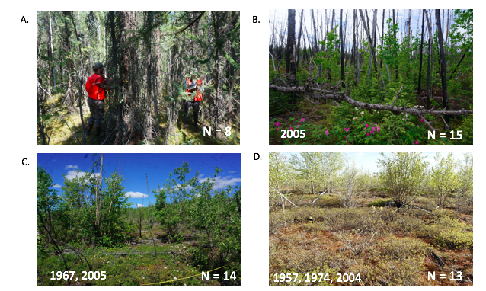

Figure 2

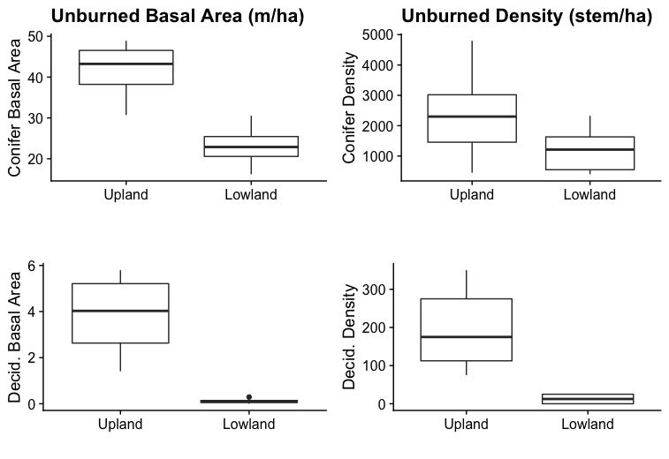

Figure 3



Figure 4



Figure 5

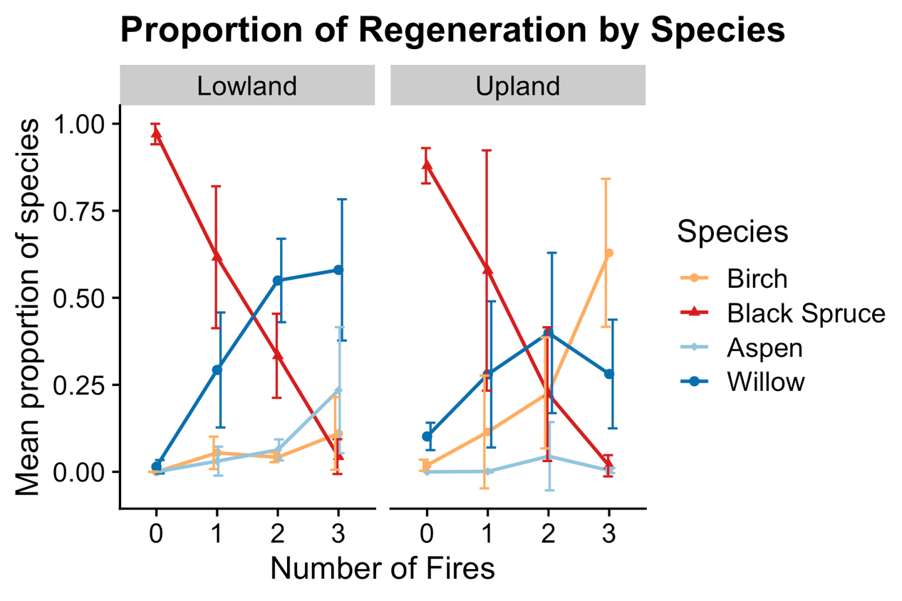

Figure 6

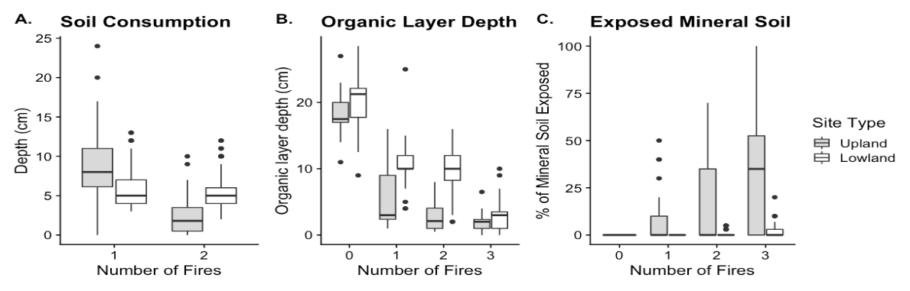

Figure 7

# 